Seth Dry – Team Second Report
MCEN 5151 November 3rd, 2025
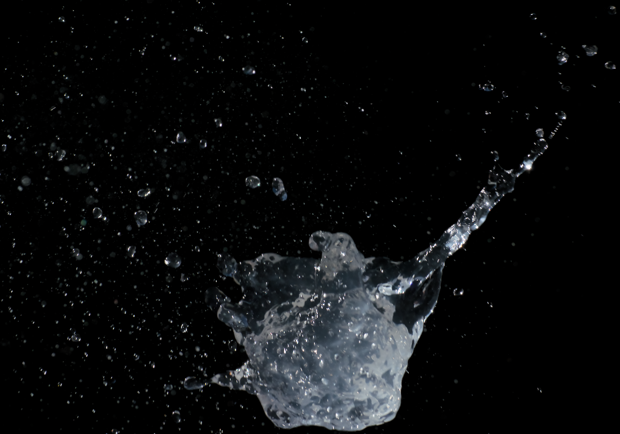
Figure 1 – Final Image
For this second flow visualization assignment I worked with my groupmates Haiying Peng and Iker Acha to capture the moment after a water ballon is popped with a needle. Our final image is shown in figure 1 above. Our intention with this flow visualization was to capture the jetting and droplet expulsion that we thought would happen after then balloon was popped, and indeed these phenomena are captured in the final image. The largest constraint in the capturing of these phenomena, both scientifically and artistically, was to have appropriate time resolution to effectively freeze such a short-lived event. We were also concerned with having enough contrast between the background and the subject to be able to clearly distinguish the fluid phenomena. In the final image we can see that we were successful on both counts, the motion of the fluid is effectively frozen in time, and the background we used was sufficiently dark to clearly distinguish the fluid.
There are a few interesting phenomena shown in this image. The first is the more pronounced jet that can be seen in the upper right-hand corner of the image. This longer jest coincides with where the needle initially popped the ballon and provided a nozzle for the water to flow through as it was initially propelled by the elastic force of the water ballon. This jet would have formed first, and as the ballon shed away, and the size of the “nozzle” increased, the jet becomes less pronounced. The next phenomenon of note is the spatter of droplet coming away from the center mass of water. These droplets likely formed as the ballon shed off the body of water and imparted a shearing force on the surface sufficient to create these droplets. We can also see the beginning of the downward motion and elongation of the mass of water as gravity becomes the greatest force influencing its motion.
To analyze these phenomena, it will be first helpful to calculate the temporal resolution and tangentially the size and velocity of the main jet and droplets. To accomplish this, we will start with the unedited image and an image of the ballon before it is popped as shown below in figure 2.
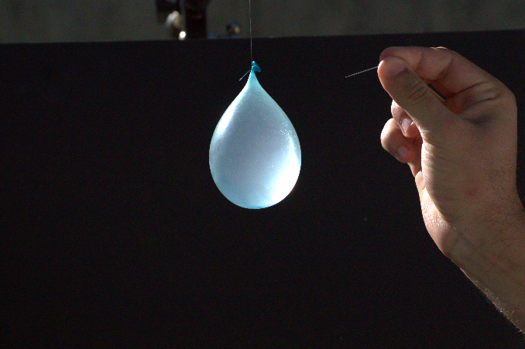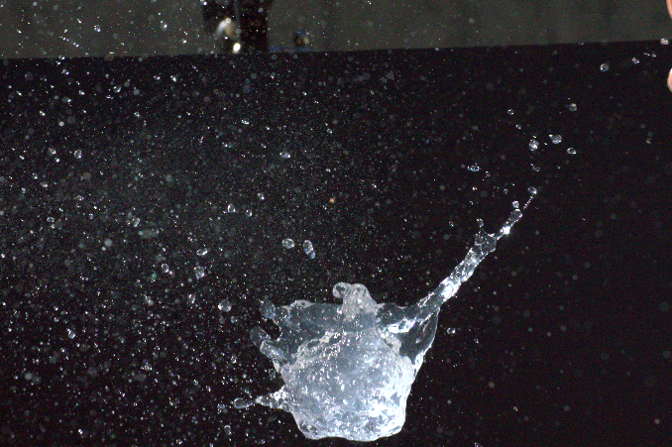
Figure 2 – Un-popped Ballon and Unedited Image
We know that the volume of water in the un-popped ballon is approximately 100 ml. Assuming the ballon is a sphere, we can calculate that the diameter of the ballon is approximately 5.76 centimeters. Both images have an equal resolution of 6034 x 4012 and were taken with the camera in the exact same position, allowing us to use the same measurement scale in each image. We can measure the un-popper ballon at 1078 pixels, giving us a scale of 187.15 px/cm. Zooming as far as we can into the image, we can see that there is a very mild motion blur, with the jet appearing to move about 7 pixels during the shutter opening for this image. This also shows the image is very well resolved temporally. The shutter speed of the camera was 1/1600th of a second. Using the scale from before we can then calculate that the flow moved .037 cm in 1/1600th of a second, or the flow was moving with a velocity of about 60 cm/s. In the same way we can calculate the width of the jet to be about 0.82 cm.
Using this information, we can calculate a few dimensionless quantities of note to examine the physics of the main jet as explored in Eggers (2008). The quantities are concerned with both the generation, and the breakup into droplets of the progressing jet. We can see this break up at the far end of the jet in the final image. These quantities are the Weber number, which describes the ratio of kinetic energy of a drop issuing from the jet, relative to its surface energy. The Ohnesorge number, which measures the relative importance of viscosity in the jet. The Bond number, which compares the effect of gravity on the progressing jet. We can also calculate a Reynold number for this jet to see the ratio of the jet’s inertia to its viscosity. The dimensionless quantities can be calculated as shown below:
$$We = \frac{ρh_{0}v_{0}^{2}}{γ}$$
$$Oh = v\sqrt{\frac{ρ}{h_{0}γ}}$$
$$Bo = \frac{ρgh_{0}^{2}}{γ}$$
$$Re = \frac{2v_{0}h_{0}}{v}$$
Where:
h₀ = Jet Radius (m) – Calculated as 0.0082 m
v₀ = jet velocity (m/s) – Calculated as 0.6 m/s
v = kinematic viscosity (m²/s) – 1x10⁻⁶ m²/s, from Lide (1978)
γ = Surface Tension (N/m) – 0.07120 N/m, from Lide (1978)
ρ = Density (kg/m³) – 995.65 g/cm³, from Lide (1978)
g = Acceleration due to Gravity (m/s²) – 9.81 m/s²
Using these values, we can compute:
We = 41.28
Oh = 0.0013
Bo = 9.22
Re = 9840
The Weber Number calculated indicates that the kinetic energy of the jet outweighs the surface tension keeping the jet together, we can see this in action in the apparent splitting apart and lack of cohesion in the jet. The Ohnesorge number shows us that the viscosity is of relatively low importance to the analysis of this jet. The Bond number shows that gravity is playing a role in the evolution of this jet, as would be expected for the falling fluid. The Reynolds number shows the turbulence of the jet, which is also visually apparent.
To capture this image of a water balloon being popped we used a fairly simple setup, which can be seen in figure 3 below. The ballon to be popped was suspended from a tripod in front of a black poster board background, positioned over a container to catch the falling liquid. The camera was placed on a tripod, level with the ballon, about 5 ft away. To capture the image, I used the burst shooting mode as one of my group mates popped the ballon using a sewing needle. Doing this a few times, we were able to eventually capture the moment just after the balloon popped, but before the water fell out of frame. The images were captured using sunlight to light the scene, allowing for us to use sufficiently faster shutter speeds to achieve good temporal resolution.
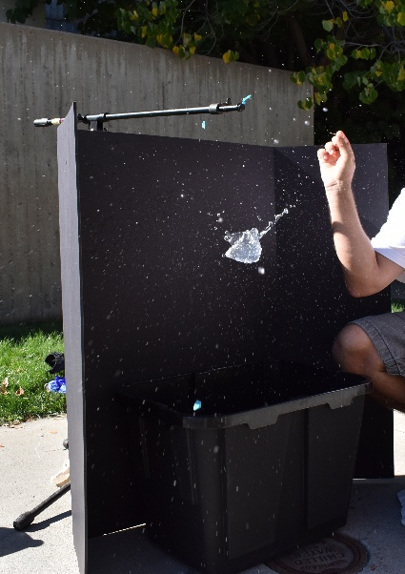
Figure 3 – Flow Setup
The original image, as shown in figure 2 was shot using a Nikon model D3200 DSLR camera. The FOV is approximately 27 inches, and the camera is about 5 ft away from the subject, the lens has a focal length of 80mm. The image was captured shutter speed priority, with a shutter speed of 1/1600th of a second, the aperture was set by the camera at f/14. The exposure compensation was also set to -0.3 to compensate for blown out portions caused by the intensity of the direct sunlight. The ISO was set to 400. The original image had a resolution of 6034 x 4012 px, and the final cropped image has a resolution of 4414 x 3093 px. Post processing on this image was performed using dark table, and besides the crop used two main tools. The first was to use the tone equalizer tool to make the black background absolutely black. Then the RGB curves tool was used to adjust the relative exposure of shadows and highlights in the mass of water and the droplets to provide the most contrast and detail in both the highlights and shadows. The unedited image is shown in figure 2.
This image captures an interesting glimpse of the creation of a jet as a water balloon is popped, this jet forming from the pressure difference between the interior and exterior of the ballon and the small nozzle created at the initial puncture. We can see from the image some classical jet features, such as the breakup of the jet as it evolves further from the nozzle. The image also gives a good sense of the speed of the image, and the instantaneous popping phenomena that can hardly be seen by the human eye. This image is an interesting exploration in non-trivial physics that can be created by such a simple, and even common activity.

References
J. Eggers and E. Villermaux, “Physics of liquid jets,” Rep. Prog. Phys., vol. 71, no. 3, p. 036601, Feb. 2008, doi: 10.1088/0034-4885/71/3/036601.
D. R. Lide, G. Baysinger, S. Chemistry, L. I. Berger, R. N. Goldberg, and H. V. Kehiaian, “CRC Handbook of Chemistry and Physics”.

