Clouds Second Report
Andrew Mord
MCEN 5151-001
Dec 5, 2025
Altocumulus Duplicatus
Photographed November 11, 2025 at 4:43pm MT
Superior, Colorado
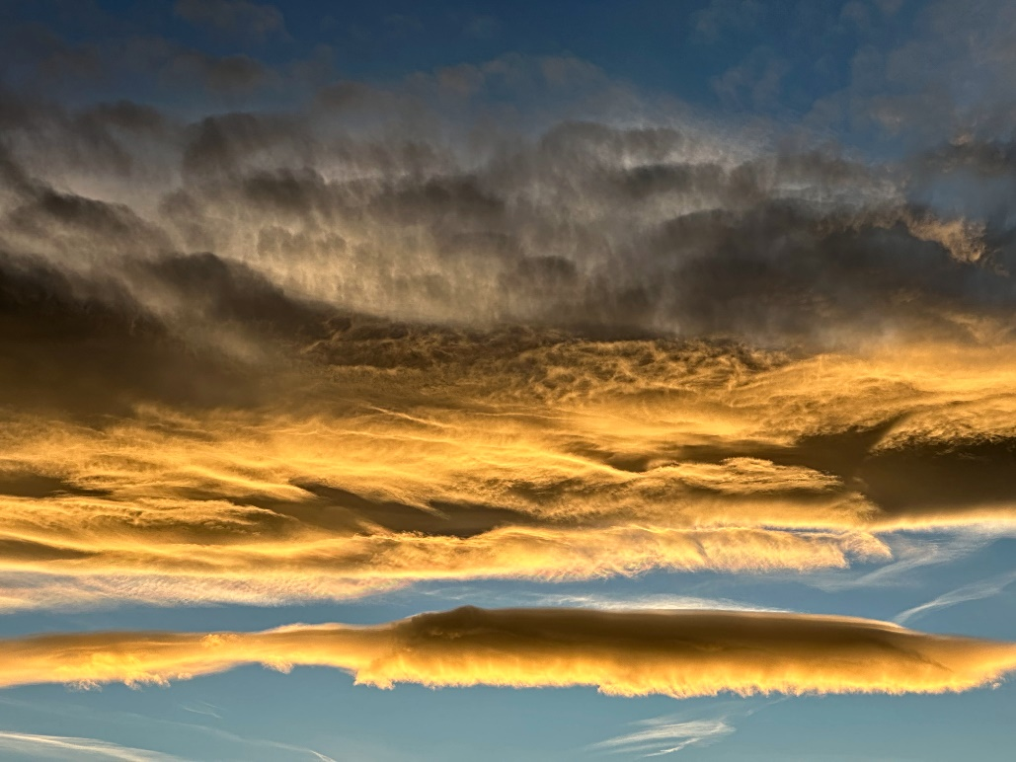
Figure 1. Final image submitted for Clouds Second assignment

Background
This photograph was taken for the last visualization assignment of the Flow Visualization course: Clouds Second. The image depicts two to three layers of altocumulus clouds at different altitudes, thus making it an altocumulus duplicatus structure. After shopping at a grocery store in Superior, CO, I was met with this spectacular view of the sunset. The intense yellows hitting the bottoms of the clouds lit up the sky in a fiery fashion.

Photo Orientation
This photo was shot out of the Costco parking lot in Superior, Colorado. It was taken November 11, 2025, at approximately 4:43pm MT. The camera was oriented west, angled well above the horizon by 30 degrees.

Cloud Observations
Roughly three layers of altocumulus clouds can be seen in the photo, therefore making it an altocumulus duplicatus species. In the bottom of the photo, one layer is distinctly wide and puffy. Towards the center and the top of the photo, two distinct layers seem to merge. Though the lighting from the sun may play some tricks, the bottom of the two layers is brightly lit up in yellow, while the top layer is gray and white. It’s worth noting the top layer is exhibiting some undulatus features, where gray cloudlets are almost organized in parallel lines. This cloud structure persisted for roughly a few hours, but the sun had set, and it was difficult to make out the details in the night. Altocumulus clouds are mid-level layer clouds made of droplets or ice crystals, forming around 2400 to 6000 meters above ground level [1]. This aligns with the data in the following Skew-T diagram, taken from University of Wyoming [2].
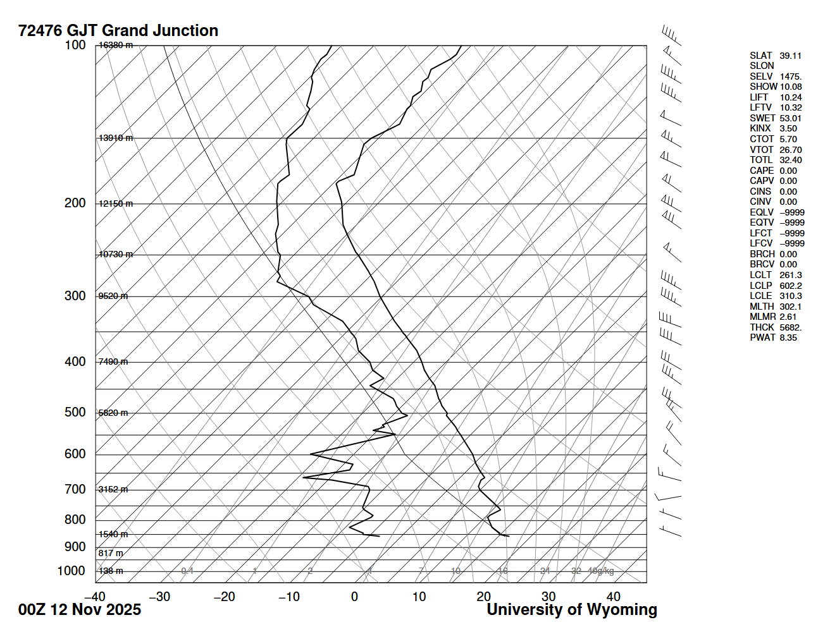
Figure 2. Skew-T plot for November 12, 2025, at 00:00 UTC (Nov. 11, 5pm MT)
Given the proximity of the dewpoint line to the measured temperature line, clouds were likely around the 5,820 meter above-sea-level mark. Though there are altitude discrepancies and geological features (mountains) in comparing Superior to Grand Junction, it makes sense for cumulus clouds to form 5,820 meters above sea level here in Superior. This translates to approximately 4,137 meters above ground level, well within the range for altocumulus. There was low winds and no precipitation, suggesting a stable atmosphere. The example temperature line appears far to the left of the balloon temperature line, meaning a stable atmosphere where rising air parcels will not be much warmer than the surrounding air and stop rising upwards. The CAPE reads 0.00 for that day, further suggesting that the atmosphere was stable. Generally, altocumulus clouds do not form from thermals that are so prevalent in an unstable atmosphere. These clouds could have formed through the breakup of altostratus or the nearby mountains producing atmospheric waves [1]. I do not recall altostratus clouds prior to capturing this photo, so it is probably the latter.

Photographic Technique
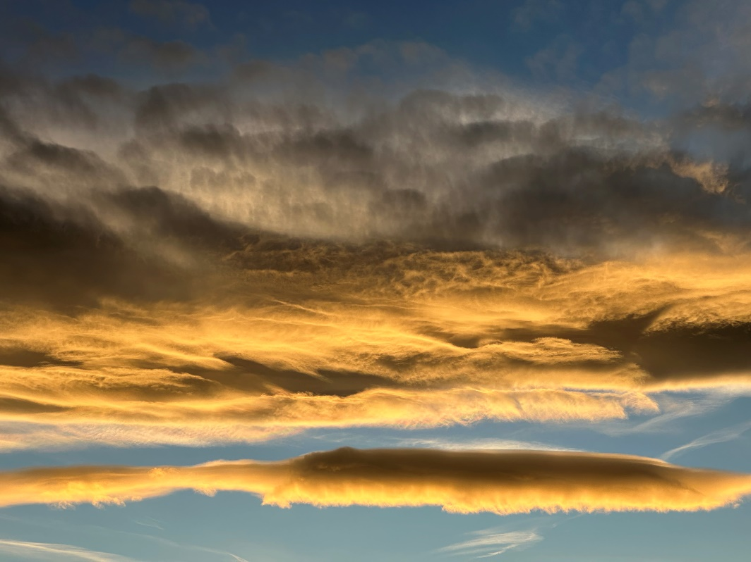
Digital manipulations were used in the final product, the primary one being contrast equalization. Mid-range contrast was boosted to bring out highlights in the clouds and deepen the shadows. A slight amount of haze removal was used to contrast the sky and upper layers of clouds. Not much thought had to be put into the camera specs as outside light was abundant and the clouds filled the frame. They stretched far beyond the borders of the photo, but I thought it was interesting to zoom in and see the details of the middle layers. The original image and camera specifications are listed below.

Figure 3. Original image

Table 1: Camera Specifications
Camera Make & Model | iPhone 14 Pro Max
Shutter Speed | 1/536
ISO | 32
Focal Length | 9 mm
Aperture | f/2.8
Original Image Size | 4032 x 3024 pixels
Final Image Size | 4032 x 3024 pixels

Conclusion
The image reveals a group of altocumulus clouds layered over top Superior, Colorado. I like how I was able to several different phenomena at sunset. The wide, bottom layers are illuminated in yellow, while the top layers are dull, but have their own developing cloudlets or undulatus. capture the fluffy, white tops of the clouds and their rainy, dark bases. I think the foreground adds a good sense of scale and frames the composition. I dislike how I could not capture the foreground in this image to give a sense of scale. Parking lot lights did not make for a visually appealing photo, so I decided to go with a cloud-only photo. I believe my original intent to capture the fiery altocumulus at sunset was fulfilled. For the future, I would like to capture more of the surrounding environment in my shots. This could be done by going to a flat region (with no streetlights or distractions) and framing the ground into view.

References
[1] Pretor-Pinney, G., “The Cloudspotter’s Guide: The Science, History, and Culture of Clouds,”
Penguin, 2006.
[2] University of Wyoming, “Atmospheric Science Radiosonde Archive.” Retrieved 17 October
2025. https://weather.uwyo.edu/upperair/sounding.shtml

