Team Third Report
Andrew Mord
Collaborators: Alyxis Ellington and Ellington Smith
MCEN 5151-001
Nov 21, 2025

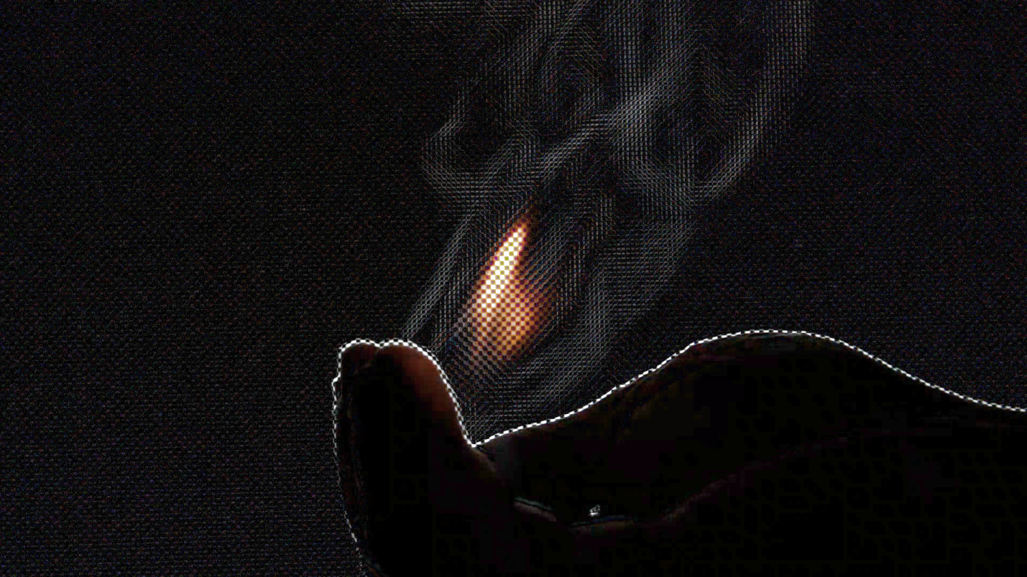
Figure 1. Thumbnail image for the Team Third video

Background
This video was taken for the fifth visualization assignment of the Flow Visualization course: Team Third. The thumbnail image depicts heat from a fire flowing out of the palm of a hand and convecting into the air above. The video was taken by filming hot objects in front of a Moiré pattern, then subtracting a duplicate video offset by a few frames. The result exploits Moiré deflectometry and reveals density gradients in the air. A solder iron shows the lighter density of air around it and propane coming out of a lighter can be seen. Propane soap bubbles are ignited in a hand and decrease the density of surrounding air.

Fluid Physics
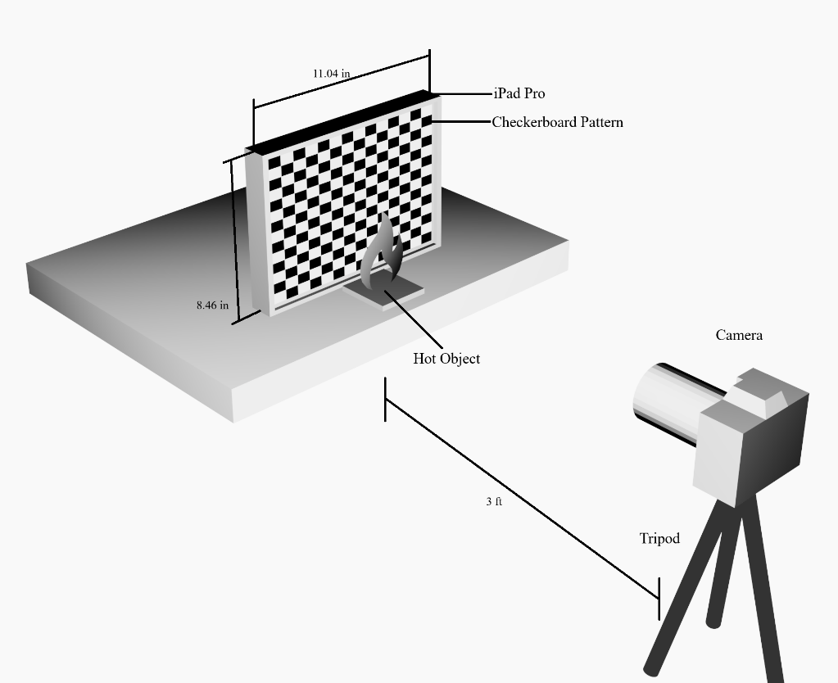
The setup used for this experiment was a 4th Gen iPad Pro (screen diagonal of 12.9”) displaying a checkerboard pattern atop a desk behind various test articles, including a solder iron, blow torch, lighter, candle, and the propane soap bubbles. A camera mounted on a tripod sat about 3 feet away from the test articles at the same vertical height. For the propane soap bubbles, the hand was dipped in cold water before grabbing the bubbles. A water bucket was on standby to drown the hand if the flames became too hot. However, the flames were only present for a few seconds, so it was not uncomfortable to hold them.
Figure 2. A diagram of the experimental setup used for the Team Third project.
Optical aberrations originate from the variations in the refractive index of air. This is directly related to air density through the Gladstone-Dale relation,
$$\begin{aligned}n=1+Κρ=1+(2.27*{10}^{-4} \frac{m^{3}}{kg})(1.225 \frac{kg}{m^{3}})= 1.000278\#\left(1\right)\end{aligned}$$
where n is the refractive index of air, $Κ$ is the Gladstone-Dale constant, and $ρ$ is the air density [1]. For standard atmospheric air at 15° C, the air density is 1.225 kg/$m^{3}$, which yields a refractive index of 1.000278. The Gladstone-Dale constant holds for temperatures below 6000° C, above which, air molecules break apart. Above a candle flame, air temperatures can reach up to 1400° C, yielding an air density of 0.2109 kg/$m^{3}$ and a refractive index of 1.0000479. Light travels a mere 0.023% faster in the hotter air, causing distortions in the image. What may seem like a small change in the refractive index leads to noticeable density gradients in the context of Background Oriented Schlieren (BOS). Indeed, even lower energy outputs like body heat can be visualized with this method. A good indicator of whether a flow can be seen by Schlieren imaging is the Grashof number, which represents the ratio of buoyancy forces to viscous forces in a fluid.
$$\begin{aligned}Gr= \frac{gβ∆TL^{3}}{υ^{2}}=\frac{9.81\frac{m}{s^{2}}*\frac{1}{300 K}*1100 K*{0.03}^{3} m}{{(1.5*{10}^{-5} m^{2}/s)}^{2}}= 4,316,400\#\left(2\right)\end{aligned}$$
$β$ is the thermal expansion coefficient, often 1/$T_{amb}$ for an ideal gas. $∆T$ is the difference between the hot gas and ambient gas, so 1400 K – 300 K. L is the characteristic length, often the diameter of the initial hot gas plume, so 3 cm. $υ$ is the kinematic viscosity of ambient air and g is the gravitational constant. When it comes to Schlieren imaging, a low Grashof number (<10⁶) corresponds to weak, gentle shimmering of refractive-index gradients [2]. Plumes are dominated by friction forces, so they rise slowly. BOS distortions are small and localized. Body heat and solder iron heat fall in this regime since they are difficult to detect with this method. For high Grashof numbers (>10⁸), buoyancy forces are large relative to viscous forces. Hot gas rises rapidly, causing strong entrainment, mixing, and turbulence. This produces many strong density gradients, leading to easier visualization in BOS. This was observed with the blowtorch. For propane soap bubbles, the Grashof number falls somewhere between 10⁶ < $Gr$ < 10⁸. This region shows a balance between buoyant forces and viscous forces, so rolling vortices or mushroom-cap plumes can be seen. Flow will often transition from laminar to turbulent wakes following hot parcel of air. These structures were observed, especially at the start of ignition, where big mushroom-caps floated upwards with trailing vortices behind.

Visualization Technique
Moiré-Based Schlieren imaging was the main technique used for this experiment. It is a form of BOS, but has not been well-defined in the literature. The technique is accomplished by taking a video of a hot object in front of a moiré pattern, such as a fine checkerboard or fine gridded lines, duplicating the video, and taking the difference between the two videos with one offset by a few frames. Post-processing techniques are discussed further in the next section. The moiré effect appears when to overlapping repeating patterns are slightly misaligned, leading to wavy or rippled patterns. This can often be seen when taking pictures of a computer screen with another device and wavy pixel patterns appear. An iPad was used as the backdrop for the moiré pattern since the brightness level and zoom level of the pattern could easily be modified. Since flames are easily visualized with this method, it took a couple of iterations to find the right brightness level and zoom level. Ultimately, the team settled on having room lights off where the only light source came from the flame and iPad screen set to about 50% brightness. The zoom level was set to where roughly 250 x 141 checkerboard squares occupied the iPad screen. The checkerboard pattern itself was generated in Aseprite, a pixel editing software, at a resolution of 1280 x 720 pixels, then upscaled to 12800 x 7200 pixels to view on the iPad. The upscaling helped fight image compression near the corners of the checkerboard squares, which are critical to have well-defined for the technique to work. When the difference between the footage is taken, density gradients show up on the corners of the checkerboard squares leading to coherent hot gas structures throughout the frame.

Photographic Technique
Digital manipulations were applied to the footage to achieve the Moiré-Based Schlieren imaging technique. When a single video is duplicated and layered on top of each other, the top video is displaced by a few frames forward, while the layer it’s on is set to ‘Subtraction’ or ‘Difference’ blend mode or compositing mode. These settings can be found in video editing software such as DaVinci Resolve and Sony Vegas Pro. To get the density gradients to show up even more, contrast and brightness were increased to the whole video. The footage appeared to flicker brightly sometimes, so a flash warning was advised at the start of the video. An important consideration to make was the refresh rate of the iPad and camera recording frames per second (fps). The video was shot at 30 fps, while the iPad ran close to 120 Hz (however, the refresh rate is dynamic, so the true refresh rate was unknown). For an ideal video, the camera fps should be set to a prime number, while the refresh rate of the backdrop should be relatively high and indivisible by the fps. This will reduce ‘flicker’ in the video, although it was not unbearable in our final product. An alternative method to Moiré-Based Schlieren can be to take a picture of the backdrop in undisturbed air, then subtracting the video footage from the picture. This method was attempted; however, it did not show the density gradients well. We believe this is attributed to small disturbances made to the camera between taking the initial picture and video (i.e. footsteps, pressing the record button). A well vibrationally-damped tripod or base is advised to use with this method
Since one checkerboard square measures about 9 pixels across, and the hand measures 165 mm or 140 checkerboard squares, the spatial resolution was about 7.64 pixels/mm. The camera sat about 3 feet away from the experiment, using a 55 mm lens. For an assumed freestream velocity of hot gas at 0.5 m/s and a frame rate of 30 fps, speed of 1/100 s, the flow translated about 16.67 mm per frame or 127 pixels. However, flow direction is not necessarily 0.5 m/s everywhere and the actual shutter speed of the footage is unknown, so the motion blur cannot be computed.
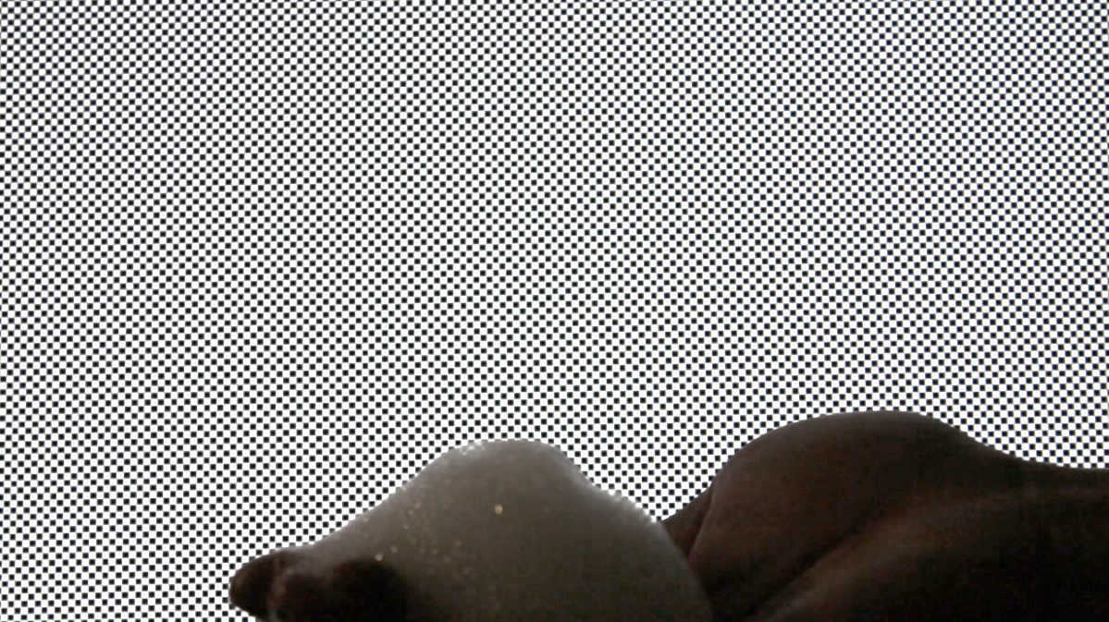
Figure 3. Sample frame from the footage with no manipulations
I think it is important to show how easily heat can be visualized using this simple method, so I included the original, unaltered footage in parts of the video. I also composed the music to match the elusive nature of this new technique. Camera specifications are outlined in the table below. The final video was rendered at twice the size to fight codec compression.
Table 1: Camera Specifications
Camera Make & Model | Canon EOS Rebel T7 1500D
ISO | 200
Focal Length | 55 mm
Aperture | f/5.6
Frame Rate | 30 fps
Playback Rate | 1.00x and 0.25x
Original Video Size | 1920 x 1080 pixels
Final Video Size | 3840 x 2160 pixels
Conclusion
The video reveals the diversity in heated air structures as the fire propagates. Some are stretched thin by the forces of wind, while others are plump and have rising mushroom-caps due to buoyant forces. I like how clearly these forces can be seen, but I dislike the fact the video has lots of flickering brightness. 127 pixels of motion per frame is not great. Having a device capable of higher fps could have helped. My original intent to capture the beauty and simplicity of this low-cost DIY Schlieren technique was fulfilled. Moving forward, I think a high-speed camera with manually configurable shutter speed would be nice to try for this experiment. I also would have experimented with different moiré patterns, like horizontal grid lines.

References
[1] Raffel, M., “Background-Oriented Schlieren (BOS) Techniques,” Experiments in Fluids,
Vol. 56, No. 3, 2015, p. 60. https://doi.org/10.1007/s00348-015-1927-5
[2] Mier, F. A., and Hargather, M. J., “Color Gradient Background-Oriented Schlieren
Imaging,” Experiments in Fluids, Vol. 57, No. 6, 2016, p. 95.
https://doi.org/10.1007/s00348-016-2183-z

