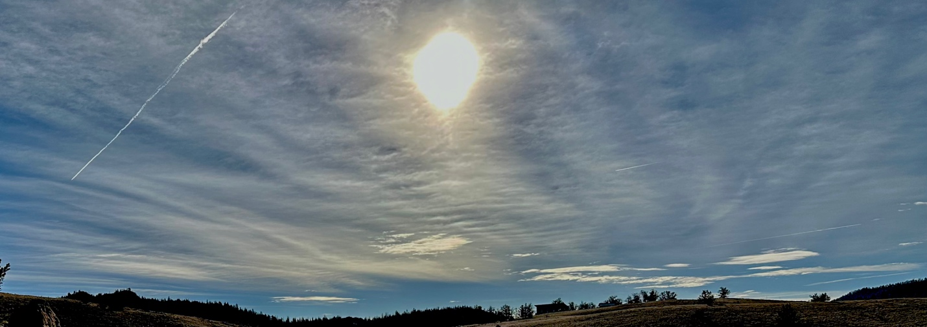
Clouds 2nd Report
Nick Rhodes
MCEN:5151 Flow Visualization

Context and Purpose
This image was taken for the second cloud assignment with the goal of showing an altostratus cloud and relating the appearance to the profile shown in the skew T chart, shown in appendix B. The intent was to capture a representative cloud field and use the Skew-T to interpret cloud type, cloud-base height, stability, and formation.
Circumstances of the Image
The photograph was captured at an elevation of 9,000ft in Jefferson, Colorado facing south with an approximate elevation angle of 20–25° above the horizon. The photo was taken on 26 October 2025. Conditions at the time were calm at the surface with mostly uniform mid-level cloud cover across the southern sky.
Cloud Identification and Atmospheric Analysis
The cloud displays a smooth, semi-transparent sheet and a clearly diffused solar disk. These features indicate Altostratus translucidus as the dominant cloud layer, accompanied by Cirrostratus and patches of thin cirrus, including a persistent contrail [1]. Supporting data come from the 12Z SLC Skew-T (26 October 2025), which shows a very dry boundary layer with a large dewpoint depression below roughly 650 mb. A nearly saturated layer from ~500–300 mb corresponds to typical altostratus cloud-base and cloud-top altitudes of approximately 5–8 km, consistent with the visual appearance. Above 300 mb, a narrow region of ice supersaturation is present, matching the observed thin cirrus and long-lived contrails. The sounding shows weakly stable to moist-neutral lapse rates in mid-levels and increasing wind speeds with height, with slight veering. This vertical wind shear explains the banded texture and horizontal spreading of upper-level ice clouds. The broader weather pattern, including moist air moving in from the Pacific, gentle upward motion ahead of the approaching system, and some lifting as winds crossed the Rockies, supplied the cooling needed for the mid-level clouds to form [1].
Photographic Technique
The image was taken on an iPhone 14 Pro using the 24 mm equivalent main lens. The native image resolution was 4032 × 3024 pixels. Exposure settings were automatically selected by the camera: ISO 32, f/1.78, and 1/1200 s shutter speed. No zoom was applied. The field of view is approximately 70° horizontally. Image processing consisted of minor contrast reduction and highlights adjustment to preserve the appearance of the diffused solar disk; no color alterations or structural edits were made. The foreground was cropped to remove distracting elements. The original image can be seen in appendix B. These choices were made to ensure the cloud layering and texture remained natural and representative.
Image Interpretation and Evaluation
The image clearly reveals a smooth mid-level cloud sheet with upper-level ice clouds above it, matching the structure of the atmosphere shown in the Skew-T chart. The layered texture highlights the laminar flow in a stable environment, while the diffused sun illustrates ice-crystal in cirrostratus. The image fulfills the original intent by capturing a clean example of altostratus with accompanying cirrus. A wider field of view might have improved the depiction of horizontal extent, and a slightly higher elevation angle could have shown more vertical structure.

Appendix A:
References
1. American Meteorological Society (AMS). Glossary of Meteorology – Altostratus, Cirrostratus, Contrails.
2. University of Wyoming Department of Atmospheric Science. Upper-Air Soundings and Skew-T Log-P Diagrams.

Appendix B:
Skew T Chart:
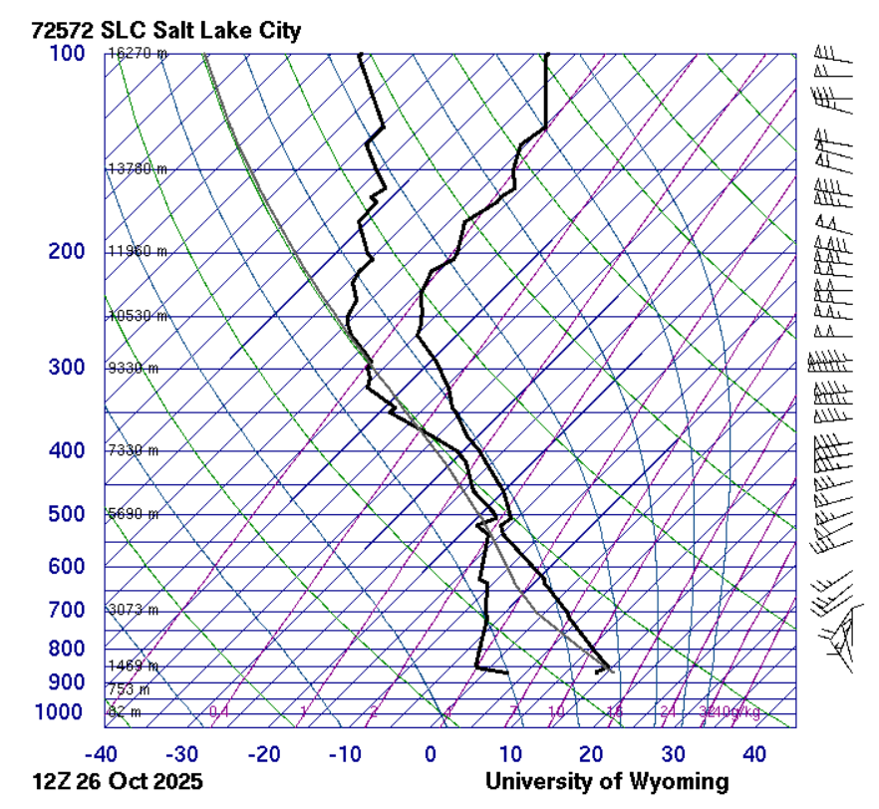
Original Image:
