Clouds First Report — Flow Visualization
Altocumulus over the Grand Canyon at Sunset



Connor L. Arnold
Professor: Laura Sunberg
MCEN 5151-001

Department of Aerospace Engineering Sciences,
University of Colorado Boulder, Boulder, CO, 80303
10/15/2026

Nomenclature
c_{p} = Specific heat of air, J/(kg·K)
d = Distance from camera to cloud, km
g = Gravitational acceleration, m/s²
p = Pressure, mb
p_{b} = Pressure at the cloud base, mb
p_{rim} = Pressure at the rim, mb
p_{t} = Pressure at the top of the cloud layer (upper inversion), mb
R_{d} = Gas constant for dry air, J/(kg·K)
$R_{E}$ = Effective radius of the Earth, including atmospheric refraction, km
T = Temperature, °C or K
T_{d} = Dewpoint temperature, °C
T̄ = Mean temperature of an atmospheric layer, K
W = Horizontal width of the field of view at the cloud, km
z_{rim} = Elevation of the observer (Hopi Point), m
α = Angle of view of the camera (horizontal or vertical), °
Γ = Environmental lapse rate, K/km
Γ_{d} = Dry lapse rate, K/km
Γ_{m} = Moist lapse rate, K/km
Δz = Thickness of the cloud layer, m
Δz_{b} = Height of the cloud base above observer, m
θ = Elevation angle above the horizon, °

I. Introduction
For the Clouds First assignment, I set out to photograph a mid-level cloud layer lit by the setting sun and connect its structure to the stability shown in the nearest atmospheric sounding. The image, shown in Figure 1, captures altocumulus clouds over the Grand Canyon just after sunset and shows how a stable, layered atmosphere organizes condensed water into a thin sheet of rounded cells [1]. Artistically, the photograph uses a long telephoto lens to compress the distant cloud layer into stacked bands of orange and red above the dark silhouette of the far rim. The same cellular pattern appears in many places in nature, and in each case it signals fluid overturning inside a layer that is capped from above [2].
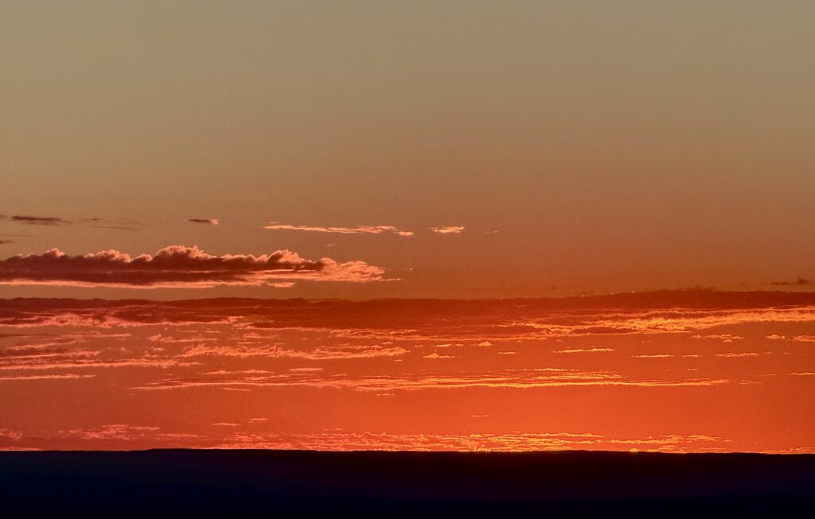
Figure 1: Altocumulus over the Grand Canyon at Sunset (final image)
1.1 Location and Timing
The image was taken on October 5, 2026, at 6:09 PM MST (01:09 UTC on October 6) from Hopi Point, Grand Canyon National Park, Arizona, at an elevation of approximately 2,150 m. The camera faced west-southwest at an elevation angle of roughly θ = 2° above the horizon, and the clouds in the frame were roughly 50-150 km away. The photo was taken a few minutes after local sunset, with the sun just barely below the horizon, so the cloud layer was still lit from below by low-angle sunlight while the canyon was in shadow.
II. Discussion
2.1 Cloud Identification
To analyze the fluid dynamics in the image, the main cloud features and the atmospheric conditions behind them are identified first. The clouds in the image are altocumulus, a mid-level cloud made of rounded cells or rolls arranged in a layer. Each cell marks a small region of rising, saturated air, and the thinner or clear gaps between cells mark where air sinks and evaporates. This cellular pattern is the most visible flow feature in the image, as shown in Figure 2. Because the clouds are far away and seen at a low angle, the large cloud at the left shows the lumpy, rounded tops of individual cells, while more distant parts of the layer are compressed into thin, bright streaks.
The bases of the cells are flat and sit at nearly the same height across the frame. A flat base forms where rising air first reaches saturation, so it corresponds to the condensation level in the sounding. The cell tops are also limited in height, which points to a stable layer above that stops vertical growth.
Gaps between cells
(indicate sinking, drier air)
Cells lit from below
Horizon/rim silhouette
Sunset below horizon
Flat cloud base
Thin wisps/cell fragments
Clear sky above the cloud layer
Rounded altocumulus cells
(indicates convection within layer)
Figure 2: Altocumulus Layer Analysis Diagram
2.2 Atmospheric Conditions
The nearest upper-air sounding is from Flagstaff, Arizona (station FGZ), about 110 km southeast of Hopi Point. The sounding in Figure 3 is valid at 00Z October 5, about 25 hours before the photo was taken at 01:09 UTC on October 6; the 00Z October 6 launch, about an hour after the photo, would be a closer match [3]. The clouds were also 50-150 km west of the camera, so the sounding describes the general air mass rather than the exact column the clouds formed in.
In Figure 3, the surface temperature and dewpoint are 21.7°C and 5.6°C, and the lifting condensation level (LCL) sits near 620 mb [4]. The convective condensation level (CCL), where the base of clouds is formed by surface heating, is higher at 560 mb. The temperatures possess two inversions, the first being a nearly isothermal layer near 690-680 mb and the second being a sharper inversion near 500-490 mb. Between these two points the dewpoint depression is large as well (approximately 18-21 °C) which indicates that the mid-levels would be dry when this sounding was taken. Additionally, the winds between 700 and 500 mb were light easterlies of about 10-20 kt.
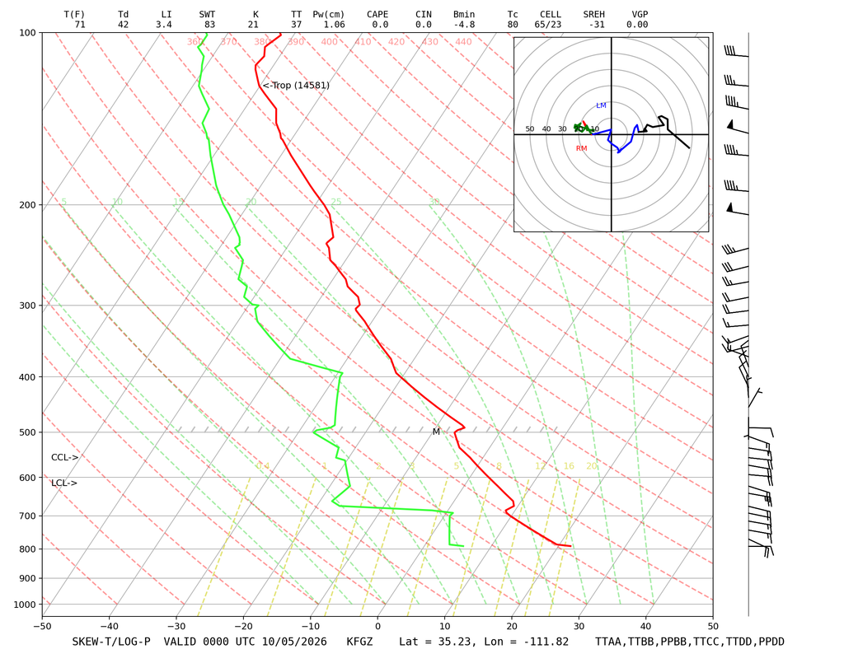
Figure 3: Skew-T Diagram, Flagstaff, AZ (FGZ), 00Z October 5, 2026
  - Analysis
To characterize the cloud layer, the properties of dry air, R = 287 J/(kg·K), c_{p} = 1004 J/(kg·K), and g = 9.81 m/s² were used, along with the pressures and temperatures read from Figure 3, listed below.
- Observer (Hopi Point): z_{rim} = 1,951 m, p_{rim} = 790 mb, and surface T = 21.7°C/T_{d} = 5.6°C
- Cloud base (LCL): p_{b} = 620 mb and T = 4.9°C
- Upper inversion: p_{t} = 500 mb and T = -6.7°C
- Inversions: 690-680 mb and 500-490 mb
The height of the cloud base above the photo location can be found using the hypsometric equation, Equation 1 [2]. This equation utilizes the thickness of the atmospheric layer, the ratio of the pressures at its bottom and top, and the layer’s mean temperature.
${Δz}_{b}=\frac{R_{d}\overline{T}}{g}\ln\left(\frac{p_{rim}}{p_{b}}\right)$ (1)
Taking the LCL as the cloud base and using a mean temperature of T̄ = 286.5 K between the rim and 620 mb the cloud base can be computed.
$${Δz}_{b}=\frac{\left(287 J {kg}^{-1} K^{-1}\right)\left(286.5 K\right)}{9.81 m s^{-2}}\ln\left(\frac{790 mb}{620 mb}\right)= 2,030 m$$
Based on the calculations the cloud base sits at roughly 2.03 km above the rim, being within the 2-6 km range typical of mid-level altocumulus [2]. The same calculation can be done with the CCL at 560 mb, placing the base at about 2.9 km above the rim. If the hypsometric equation is applied between the LCL and the upper inversion, then the maximum cloud thickness can be determined, seen in Equation 2.
$Δz=\frac{R_{d}\overline{T}}{g}\ln\left(\frac{p_{b}}{p_{t}}\right)$ (2)
With the average temperature being T̄ = 272.2 K between 620 mb (4.9°C) and 500 mb (-6.7°C), we can then solve for the cloud layer thickness, seen below.
$Δz=\frac{\left(287 J {kg}^{-1} K^{-1}\right)\left(272.2 K\right)}{9.81 m s^{-2}}\ln\left(\frac{620 mb}{500 mb}\right)= 1,710 m$
The layer is at most about 1.7 km thick, placing the highest possible cloud tops near 3.7 km above the rim. The stability can be judged by comparing the lapse rate with the dry/moist adiabatic lapse rates. Using the temperatures found at the LCL and the upper inversion, the lapse rate across the cloud layer can be found using Equation 3.
$Γ=-\frac{ΔT}{Δz}=-\frac{\left(-6.7 - 4.9\right)K}{1.71 km}= 6.8 K {km}^{-1}$ (3)
The dry adiabatic lapse rate is found using Equation 4 [2].
$Γ_{d}=\frac{g}{c_{p}}=\frac{9.81 m s^{-2}}{1004 J {kg}^{-1} K^{-1}}= 9.8 K {km}^{-1}$ (4)
For saturated air at 0°C and 560 mb, the moist adiabatic lapse rate is approximately Γ_{m} = 5.4 K/km [2]. A layer is stable when Γ < Γ_{m}, conditionally unstable when Γ_{m} < Γ < Γ_{d}, and unstable when Γ > Γ_{d}. With a lapse rate of Γ = 6.8 K/km, the cloud layer can be identified as conditionally unstable. The inversions, however, behave very differently. At the lower inversion the temperature stays constant, from 8.8°C at 690 mb to 8.9°C at 680 mb (Γ = -1 K/km) and at the upper inversion it rises from -6.7°C at 500 mb to about -5.9°C at 490 mb (Γ = -5 K/km). The lower inversion is weak, so the strong afternoon thermal changes are able to push through it, but the upper inversion is stronger and, as a result, caps the cloud layer.
Observations of the sky and weather around the time of the photo support this picture. Apart from the altocumulus in the image, the sky was completely clear, and the previous day had been sunny with no clouds at all, so this layer formed on October 5 rather than lingering from an earlier weather system. No front was approaching, no rain or snow fell within a few hours of the photo, and winds were very light. Together, these point to a calm, stable air mass rather than large-scale frontal lifting: without a front to force widespread rising motion, cloud formed only where the layer between roughly 620 and 500 mb became locally saturated, producing an isolated patch of cells in an otherwise empty sky. The cloud-free day before is also consistent with the dry mid-levels in the sounding, which was launched during that clear period, and the light winds match the weak, uniform winds through the cloud layer in Figure 3.
Although unsaturated air in the layer is stable, the conditional instability found above means that once the layer saturates, overturning can happen within the cloud itself. Cool, dense air at the top of the layer sinks while warmer air below rises, forming small convective cells confined to the layer [4, 5]. The inversion at 500 mb stops these cells from rising any higher, so they spread sideways into the flat, rounded clumps seen in the image. The winds across the cloud layer in Figure 3 are light easterlies, so there is little shear within the layer to stretch the cells and the turn to westerlies above 450 mb lies above the upper inversion.
2.4 Visualization Technique
The flow in this image is visualized naturally. Lighting came from the setting sun. Although the sun had dropped below the horizon at the rim, the cloud layer was still in direct sunlight. That light traveled a long path through the lower atmosphere, where shorter blue wavelengths are scattered out, leaving the warm orange and red tones that light the cloud bases from below [2]. This low-angle lighting increases contrast between the cells and the gaps, making the cellular structure easier to see.
2.5 Photographic Technique
The image was captured with an iPhone 16 Pro Max using its 5× telephoto camera (15.66 mm actual focal length, f/2.8) with an additional 1.87× digital zoom, giving a 35 mm-equivalent focal length of about 225 mm [6]. The phone set the exposure automatically to ISO 50 and a shutter speed of 1/1248 s; the iPhone’s apertures are fixed, so ISO and shutter speed were the only exposure controls. The final image was cropped to 3746 × 2387 px. Because digital zoom enlarges the center of the 12 MP telephoto frame rather than adding detail, the true optical resolution of the image is lower than its pixel count suggests.
The very short exposure reflects how bright the sky near the setting sun was compared with the rim in the foreground. The phone’s Smart HDR processing likely merged several frames to hold detail in the bright clouds, while the rim was left as a near-black silhouette [6]. This means the tones in the original file are already partly processed before any editing.
The field of view at the cloud layer can be estimated from the camera geometry. At a 225 mm equivalent focal length, the cropped frame spans a horizontal angle of view of only α = 8.2° and a vertical angle of about 5.2°. The center of the image points only about θ = 2° above the horizon. The line-of-sight distance to the cloud base can be found from Equation 5, where the radius of the Earth $R_{E}$ = 8,500 km.
${Δz}_{b}=d\sin{θ}+\frac{d^{2}}{2R'}$ (5)
Rearranging the equation and solving for d, using the values Δz_{b} = 2.0 km gives d = 53 km for the large cloud near the center of the frame. We can then compute the horizontal width of sky captured using Equation 6.
$W=2d\tan\left(\frac{α}{2}\right)$ (6)
With d = 53 km, the field of view width (W) is determined to be roughly 7.6 km across, so each of the 3746 pixels across the frame spans about 2 m of cloud. Additionally, the field of view height can be determined using Equation 6. Using the values of d = 53 km and α = 5.2°, the height of the field of view in pixels is roughly 4.8 km tall.
Motion blur was not a concern for the image, with winds of only 10-20 kt at cloud level, the cloud moves less than 1 cm during the 1/1248 s exposure. The low viewing angle does have a cost, though as the layers of the clouds are shortened vertically, so rounded cells that would look circular from directly below appear as thin horizontal streaks from the side.
III. Conclusion
The image shows an altocumulus layer, seen nearly edge-on from 50-150 km away, with a base roughly 2.0 km above the rim and tops capped by an inversion near 500 mb. The measured lapse rate of about 6.8 K/km makes the cloud layer conditionally unstable, which, with cooling at the top during sunset, explains the rounded convective cells. The setting sun lit the layer from below, giving the image its warm color and the contrast between cells and gaps.
This image shows the structure hidden in an ordinary sunset sky. Altocumulus is often seen as background, but the repeating cells show a balance between a stable atmosphere that flattens the layer and small-scale convection that breaks it up.
The image fulfills its intent of showing a capped cloud layer, but cannot show the overturning occurring inside the cells. I like how the lens compresses the distant layer into stacked bands of orange and red, and the dark rim at the bottom of the frame. I am less happy that the distance and low angle hide most of the cell structure, so the convection is only clearly visible in the large cloud on the left. One open question is how much of the cell structure comes from cooling at the top of the cloud instead of the instability of the layer itself.
In future work I would like to film a time-lapse of the same layer through sunset to watch the cells form, drift, and break apart, and compare that motion with the winds in the sounding. Shooting a similar layer from closer underneath, with a wider lens, would show the cells face-on, making their structure and spacing easier to measure.

References
[1] C. L. Arnold, “Clouds First – Connor Arnold,” Flow Visualization, Univ. of Colorado Boulder (Oct. 2026). https://www.flowvis.org/2026/10/05/altocumulus-over-the-grand-canyon-at-sunset-stable-atmosphere/
[2] J. M. Wallace and P. V. Hobbs, Atmospheric Science: An Introductory Survey, 2nd ed. (Academic Press, 2006).
[3] Upper-air sounding, Flagstaff, AZ (FGZ), 00Z October 5, 2026. weather.uwyo.edu/upperair/sounding.htm
[4] J. Hertzberg, “Clouds 3: Skew-T and Instability,” Flow Visualization Guidebook, flowvis.org (accessed October 2026). https://www.flowvis.org/Flow Vis Guide/clouds-3-skew-t/
[5] J. Hertzberg, “Clouds 2: Why Are There Clouds? Lift Mechanism 1: Instability,” Flow Visualization Guidebook, flowvis.org (accessed October 2026). https://www.flowvis.org/Flow Vis Guide/clouds-2-why-are-there-clouds/
[6] iPhone 16 Pro - Tech Specs. Apple Support. (n.d.). https://support.apple.com/en-us/121031

